原表单
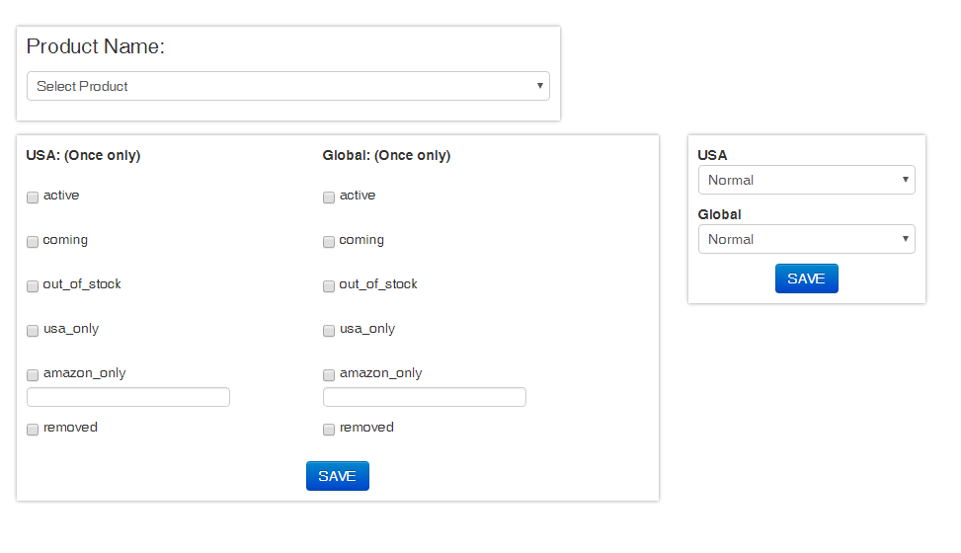

增加四个字段(红色方框部分)，条件是usa:(once only)
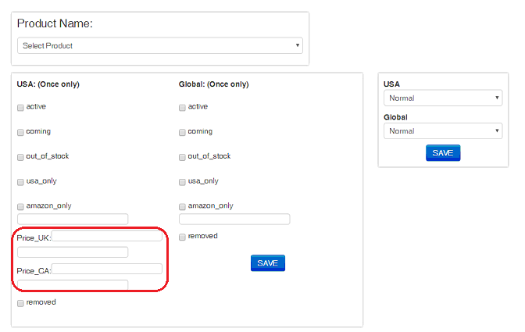

表名：
字段:
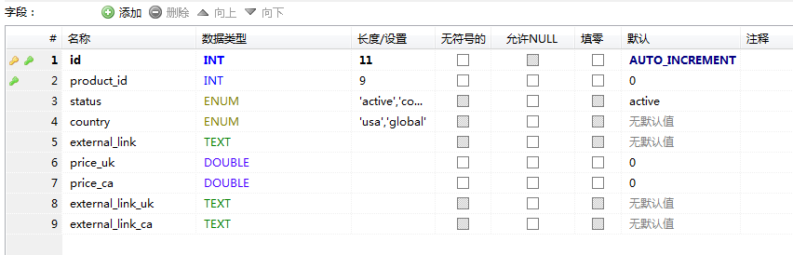

字段6.7.8.9为新增的四个字段，对应红色方框部分。

代码：

<div id="backendStatus">
<div class="selectStatus">

<div class="title">Product Name: </div>
<select class="searchStatus">
<option value="0"> Select Product</option>
<?php foreach($products as $p){?>
<?php
if( ! in_array($p['Product']['id'], $nonProducts) ){
?>
<option value="<?php echo $p['Product']['id']; ?>"><?php echo $p['Product']['id']; ?>: <?php echo $p['Product']['name']; ?> <?php echo $p['Product']['description']; ?></option>
<?php
}
?>
<?php } ?>
</select>

</div>
<div style="display:inline-block;">
<div class="addStatus">

<div id="country_usa">
<div><strong> USA: (Once only)</strong></div>
<?php foreach($status as $i){?>
<span class="each"><label><input type="checkbox" class="status_usa_<?php echo $i; ?>" name="status_usa" value="<?php echo $i; ?>"> <?php echo $i; ?></label><?php
if($i == 'amazon_only'){ ?>
<input type="text" class="amazon_only_usa">
<!-- 对应增加的四个字段 -->
<div>Price_UK:<input type="text" name="price_uk" class="price_uk"></div>
<input type="text" name="external_link_uk" class="amazon_only_uk">
<div>Price_CA:<input type="text" name="price_ca" class="price_ca"></div>
<input type="text" name="external_link_ca" class="amazon_only_ca">

<?php }
?></span>
<?php } ?>
</div>
<div id="country_global">
<div> <strong>Global: (Once only)</strong> </div>
<?php foreach($status as $i){?>
<span class="each"><label><input type="checkbox" class="status_global_<?php echo $i; ?>" name="status_global" value="<?php echo $i; ?>"> <?php echo $i; ?></label><?php
if($i == 'amazon_only'){ ?>
<input type="text" class="amazon_only_global">
<?php }
?></span>
<?php } ?>
</div>
<div style="text-align:center;">
<input type="button" value="SAVE" class="createIcons btn btn-primary"><div class="resultText_status"></div>
</div>
</div>

<div class="addEmboss">

<div id="emboss_usa">
<div><strong> USA</strong></div>
<div><select class="choose_emboss_usa">
<option value="normal">Normal</option>
<option value="emboss">Emboss</option>
</select></div>
</div>
<div id="emboss_global">
<div> <strong>Global</strong> </div>
<div><select class="choose_emboss_global">
<option value="normal">Normal</option>
<option value="emboss">Emboss</option>
</select></div>
</div>
<div style="text-align:center;">
<input type="button" value="SAVE" class="createEmboss btn btn-primary"><div class="resultText_emboss"></div>
</div>
</div>
</div>
</div>

<style>
#backendStatus{ padding: 80px 50px;}
#backendStatus .newRecommend{margin:0px; width:290px;}
#backendStatus .searchStatus{width:100%}
#backendStatus .selectStatus{ padding: 30px 0px; box-shadow: 0 1px 4px rgba(0, 0, 0, 0.22), 0 -1px 4px rgba(0, 0, 0, 0.22); max-width: 550px;text-align: left;padding: 10px; }
#backendStatus .selectStatus .title{ font-size:1.5em; margin-bottom:15px;}
#backendStatus .addStatus{ padding: 30px 0px; box-shadow: 0 1px 4px rgba(0, 0, 0, 0.22), 0 -1px 4px rgba(0, 0, 0, 0.22); text-align: left;padding: 10px; margin-top:15px; width:650px;float:left;}
#backendStatus .addStatus .each{margin-right:15px;}
#backendStatus .addStatus #country_usa{ width:300px; float:left}
#backendStatus .addStatus #country_global{width:300px; display: inline-block;}
#backendStatus .resultText_status{color:red;}
#backendStatus .resultText_emboss{color:red;}
#backendStatus .addEmboss{ padding: 30px 0px; box-shadow: 0 1px 4px rgba(0, 0, 0, 0.22), 0 -1px 4px rgba(0, 0, 0, 0.22); max-width: 550px;text-align: left;padding: 10px; margin-left:680px;margin-top: 15px;}
</style>

<script>
$(document).ready(function() {

var ajaxURL = "";
ajaxURL = document.location.protocol + "//" + document.location.hostname + "/";

var isIOS = /iphone|iPad/gi.test(navigator.appVersion);
var myDown = isIOS ? "touchstart" : "mousedown";

$(document).on(myDown, ".createIcons", function () {
var _product_id = "0";
$( ".searchStatus option:selected" ).each(function() {
_product_id = $(this).val();
});

var _usa = "";
var _global = "";

$('input:checkbox').each(function () {
if(this.checked){
<?php foreach($status as $i){ ?>
if($(this).attr('class') == "status_usa_<?php echo $i; ?>"){
_usa = "<?php echo $i; ?>";
}

<?php } ?>

<?php foreach($status as $i){ ?>
if( $(this).attr('class') == "status_global_<?php echo $i; ?>"){
_global = "<?php echo $i; ?>";
}
<?php } ?>
}
});

var _external_link_usa = "";
var _external_link_global = "";

if(_global =='amazon_only'){
_external_link_global = $(".amazon_only_global").val();
}
if(_usa =='amazon_only'){
_external_link_usa = $(".amazon_only_usa").val();
}

$.ajax({
cache: false,
type: "POST",
dataType: "json",
data: {"staus_usa": _usa, "staus_global": _global, "external_link_usa": _external_link_usa, "external_link_global": _external_link_global},
url: ajaxURL + "ProductStatuses/resetStatus/"+_product_id,
success: function (e) {

$('.resultText_status').fadeIn('fast').html(' Done');
}
});
});

$(document).on(myDown, ".createEmboss", function () {
var _product_id = "0";
$( ".searchStatus option:selected" ).each(function() {
_product_id = $(this).val();
});

var _add_button_event = $('.choose_emboss_global').find(":selected").val();
var _add_button_event_usa = $('.choose_emboss_usa').find(":selected").val();

$.ajax({
cache: false,
type: "POST",
dataType: "json",
data: {"add_button_event": _add_button_event, "add_button_event_usa": _add_button_event_usa},
url: ajaxURL + "Products/resetEmboss/"+_product_id,
success: function (e) {

$('.resultText_emboss').fadeIn('fast').html(' Done');
}
});
});

$(document).on('change', ".searchStatus", function () {
var _product_id = "0";

$('input:checkbox').removeAttr('checked');
$(".amazon_only_global").val('');
$(".amazon_only_usa").val('');

$('.resultText_status').html('');
$( ".searchStatus option:selected" ).each(function() {
_product_id = $(this).val();
});

if(_product_id > 0){
$.ajax({
cache: false,
type: "POST",
dataType: "json",
url: ajaxURL + "ProductStatuses/get/"+_product_id,
success: function (e) {
var _status = "";
var _country = "";
$.each(e.result , function( index, value ) {

_status = value.ProductStatus.status;
_country = value.ProductStatus.country;
if(_country == 'usa'){
$('.status_usa_'+_status ).prop('checked', true);
}else{
$('.status_global_'+_status ).prop('checked', true);
}

if(_status =='amazon_only'){
$('.amazon_only_'+_country).val( value.ProductStatus.external_link );
}

});
}
});

$.ajax({
cache: false,
type: "POST",
dataType: "json",
url: ajaxURL + "Products/getDetail/"+_product_id,
success: function (e) {
$(".choose_emboss_global option").filter(function() {
return $(this).val() == e.result.add_button_event;
}).attr('selected', true);
$(".choose_emboss_usa option").filter(function() {
return $(this).val() == e.result.add_button_event_usa;
}).attr('selected', true);

}
});

}
});
});
</script>

